Amazon Echo controlling garden sprinkles.

**ALEXA SERVICE**

The smart home skill API would understand the voice commands and then converts the data to json format. Which would then be sent to the smart home skills.



“Alexa turn on the water”. This will then enable the valve to turn the water on.

Smart Home Skills API

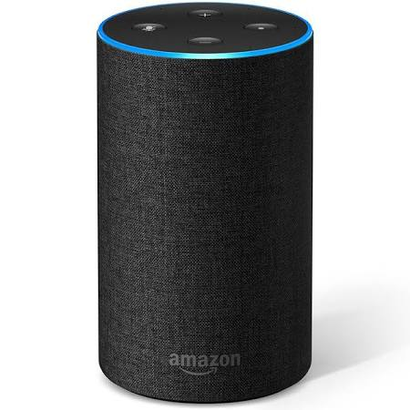



[](https://www.google.co.uk/url?sa=i&rct=j&q=&esrc=s&source=images&cd=&cad=rja&uact=8&ved=2ahUKEwj945jJqsDeAhVPqxoKHcrJBV0QjRx6BAgBEAU&url=https://www.dreamstime.com/stock-illustration-talking-teen-boy-cartoon-illustration-teenage-image47061029&psig=AOvVaw04HACc5COszJqg8gzgaJae&ust=1541613112929363)

Then converting the messages to JSON format.

Request is sent to turn the water sprinkler on from the smart home api, e.g. the app on the smart device.

The user, would interact with Alexa enabled devices or they can use the remote-control device to control the water sprinkler.

The response which is sent back would be successful or unsuccessful (JSON format).

Smart home skills: Converting the messages to json format and then sending message to the device cloud.

INTERNET

MQTT

Device Cloud

MQTT



Home/garden Network

Smart Home Skill Developer

Message from the device and turns the water sprinkler on. For example, on the mobile device, press on and it will turn the water sprinkler on. The AWS doesn’t talk direclt to the water sprinkler it would go through different processes in between, e.g. smart home skill api and device cloud.

[](https://www.google.co.uk/url?sa=i&rct=j&q=&esrc=s&source=images&cd=&cad=rja&uact=8&ved=2ahUKEwjO1aPWtcDeAhUtxIUKHdz1CWoQjRx6BAgBEAU&url=http://clipart-library.com/clipart/1525181.htm&psig=AOvVaw3QjyK2Gi47-e81adQXdspS&ust=1541616068501485)

**AWS Lambda Skill adapter**

**Skill registration on developer portal**

The device would then control and manage the user’s devices and then turns the water sprinkler on to water the garden, depending on the user’s request. Connections to internet are via the router.

**ACCESSING FROM VOICE CONTROL:**

Making the sprinkler system accessible by a voice command will be done by amazon echo, which would then be on and listening to the user’s voice, for it to turn the water on/off. Once it hears that, the device would then gather the voice commands which would follow and send them to a natural voice recognition service in the cloud called Alexa, which would then interpret them and sends back the appropriate response. These messages would also be published to the correct topic.

In this scenario the user would use the wake-up command to turn Alexa into an active state. Then say the command such as “Alexa turn on/off water sprinkler”. The smart home API will recognise the command and sprinkler and convert them into a JSON Message. The smart home skills interpret the JSON message and sends it to the device cloud. Cloud environment turns on cloud-enabled mentioned “sprinkler” and turns it on. If the user wanted to turn the sprinkler of, simply say “Turn off water sprinkler”.

Amazon echo would listen to whatever the user says and then sends the messages to the Alexa services for understanding. Alexa service would understand the what the user has requested and would then route to the Alexa water sprinkler API. Alexa water sprinkler API would then understand the actions, e.g. “turn on water sprinkler”. It will then send the command to the skill adapter which is hosted in AWS Lambada. The Device cloud would use this request and device name and it would then turn on the water sprinkler, depending on the users request. The skill adapter would use this data and then sends it to the user’s device cloud. All data would be returned in json format.